**Assignment**

**CSA0805 – Python Programming**

|  |  |
| --- | --- |
| **Register Number** | **192325143** |
| **Name** | **A.KARTHIKEYAN** |

**Title:**

**EXCEL DATA PROCESSOR**

**Problem Statement:**

IMPLEMENT A PYTHON PROGRAM THAT READS DATA FROM EXCEL SPREADSHEET USING THE OPENPYXL MODULE,PERFORM CALCULATION OR TRANSFORMATION ON THE DATA AND SAVES THE RESULT BACK TO THE SPREADSHEET.

**Code:**

**import os**

**import openpyxl**

**folder = r'C:\score card'**

**output_file = r'C:\score card\candidate_scores.xlsx'**

**output_wb = openpyxl.Workbook()**

**output_sheet = output_wb.active**

**output_sheet.title = 'candidate data'**

**cells = ['A6','A7','A8','A9','B1','B2','B3','B4','C6','C7','C8','C9']**

**for filename in os.listdir(folder):**

**if filename.endswith('.xlsx'):**

**file = os.path.join(folder, filename)**

**workbook = openpyxl.load_workbook(file)**

**sheet = workbook.active**

**values = [sheet[cell].value for cell in cells]**

**output_sheet.append(values)**

**output_wb.save(output_file)**

**Output Screen Shots:**

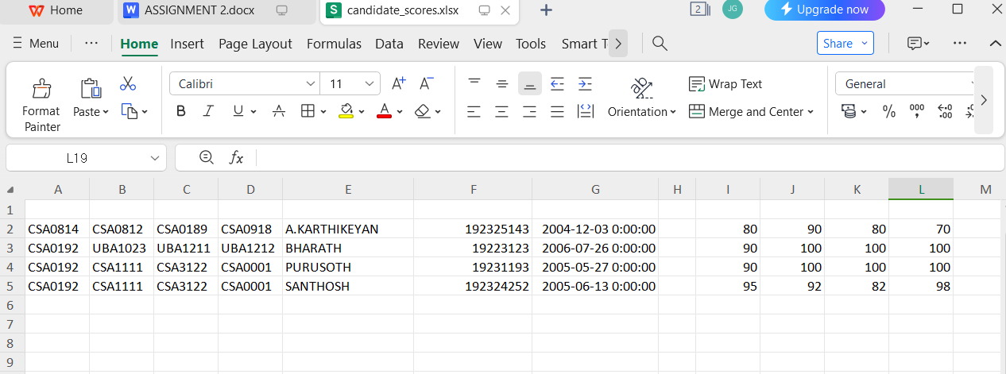

**Conclusion:**

**The above program is take 4 types of values in excel and combine it in one excel spreadsheet by using python program**

**In python we are using the openpyxl script to import the data**

**Pip install openpyxl to download the script in python and start to enter the code**

**First we have to import os and import the openpyxl for excel spreadsheet**

**And then we have the enter the location of the four files where is it located so enter the correct location of the files**

**And enter the where we want to output enter the correct location of the folder to get the output**

**And enter the occupied cells where the 4 xl files contain enter it**

**And combine it and run the program**

**The program will save at the where have gave the output files location**

**For example I gave c:score/candidate score /xlsv**

**Now I got the output above the conclusion**